How to use the Admin site

username: khimes

password: w8ng35

username: ffacco

password: dr5gl12

Go to healthy-beyond-pregnancy.herokuapp.com/admin and login with your username/password.

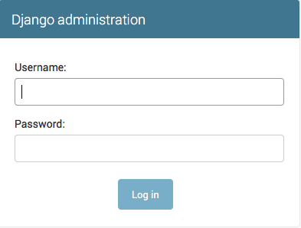

You will be redirected to the admin page, which looks like this:

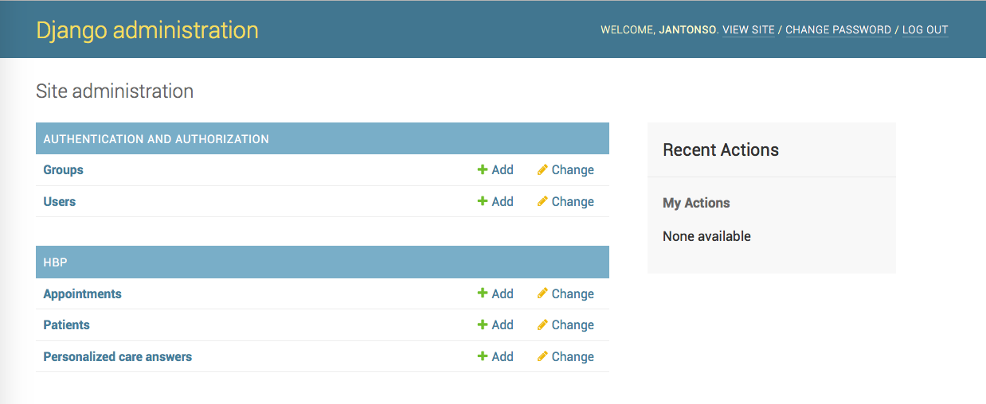

You can view and add admin users from here:

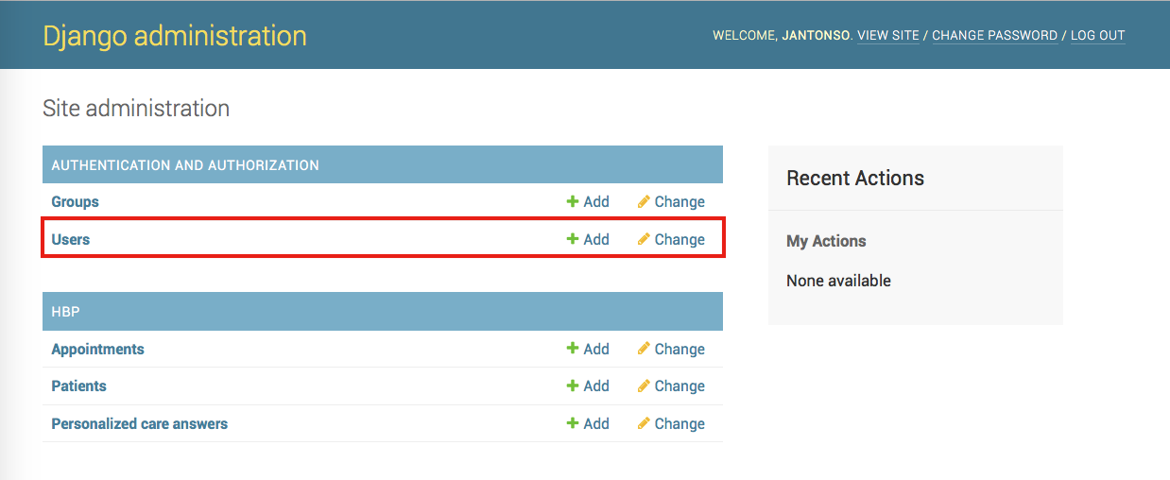

which will take you to this page:

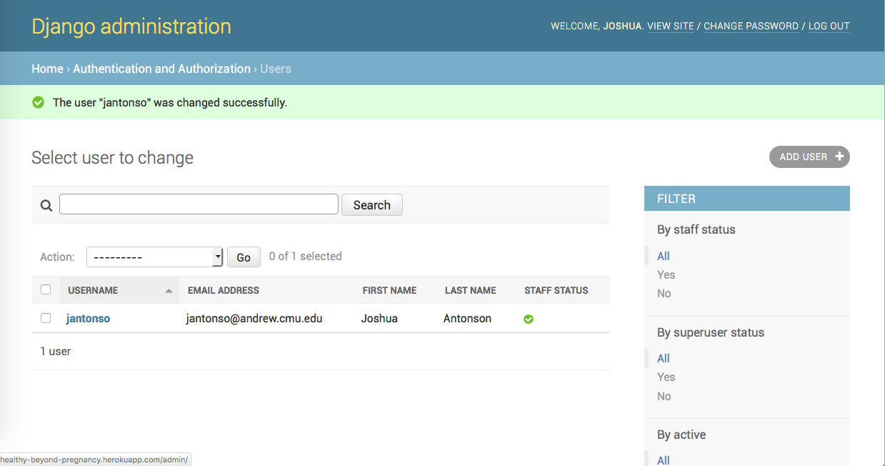

You can view and add Appointments from here:

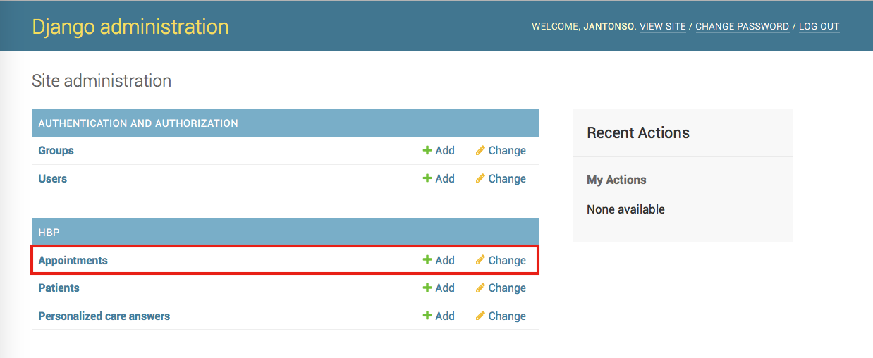

which will take you to this page:

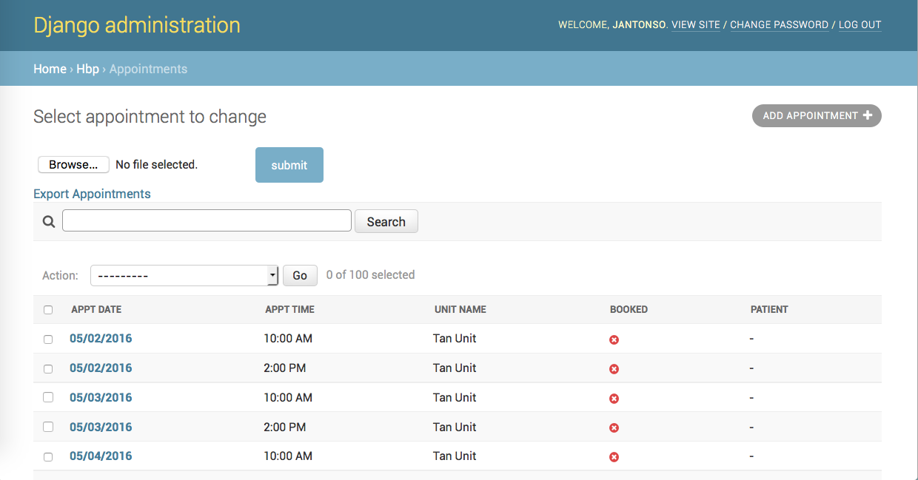

You can view and add Patients from here:

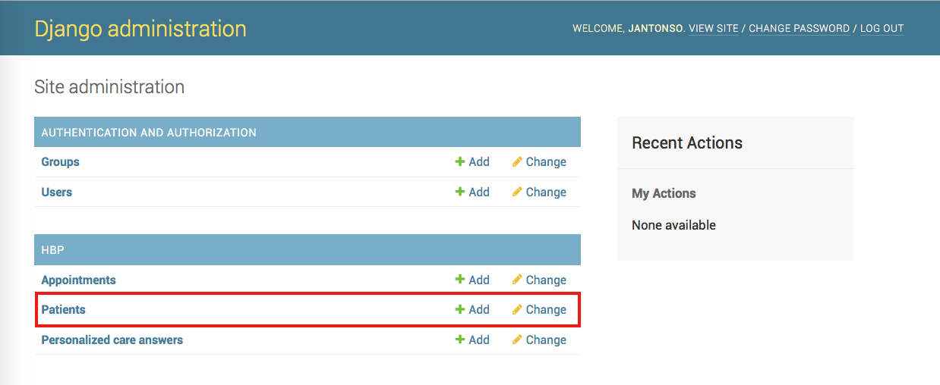

which will take you to this page:

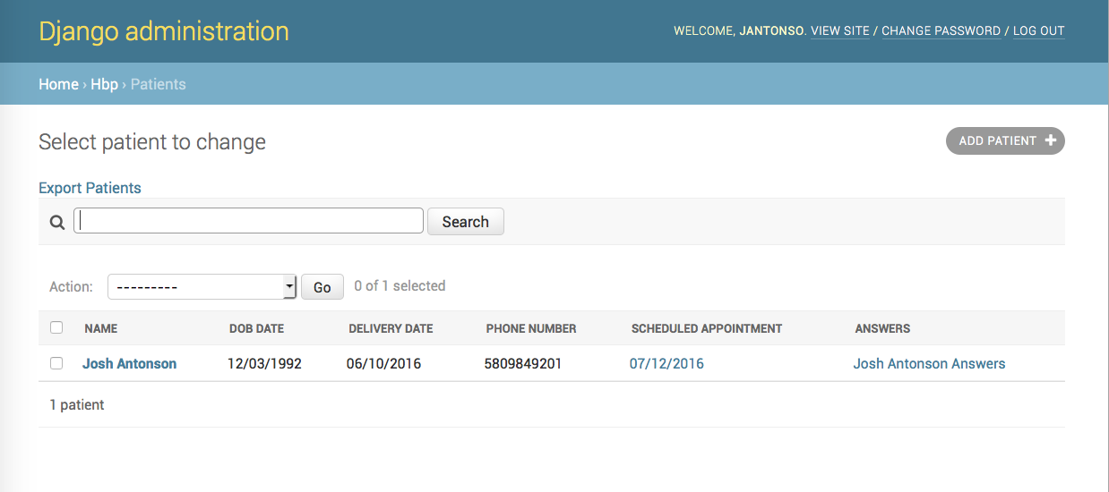

From the admin user page, you can add users

1. Click on **Add User**

2. Enter a new username / password for the user

3. Give the user superuser / staff status on the next page and click **Create**

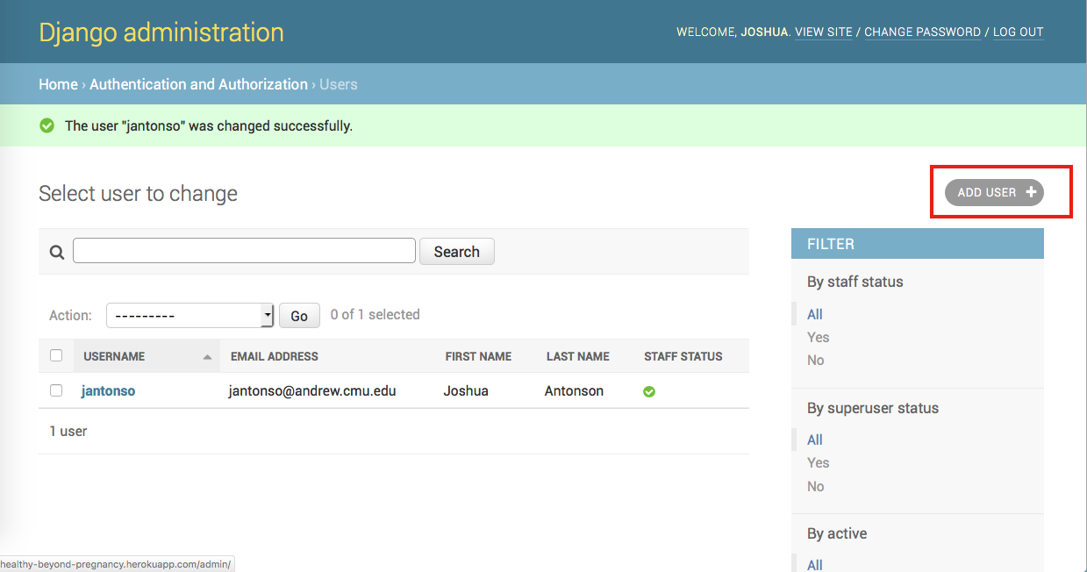

Or you can view/edit users:

1. Click on the username to view the user

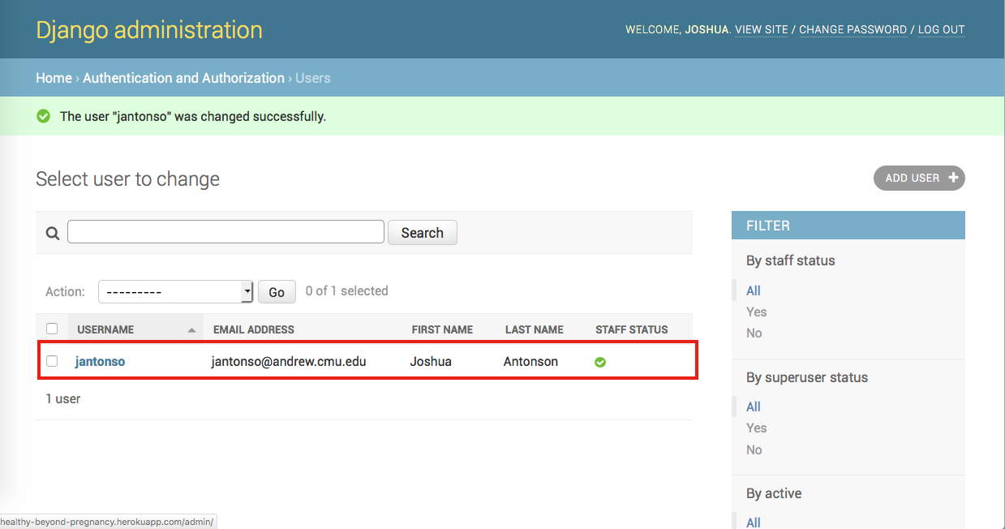

From the appointments page, you can import appointments from a CSV file:

1. Click **Browse…**
2. Select the file to import
3. Click **submit**

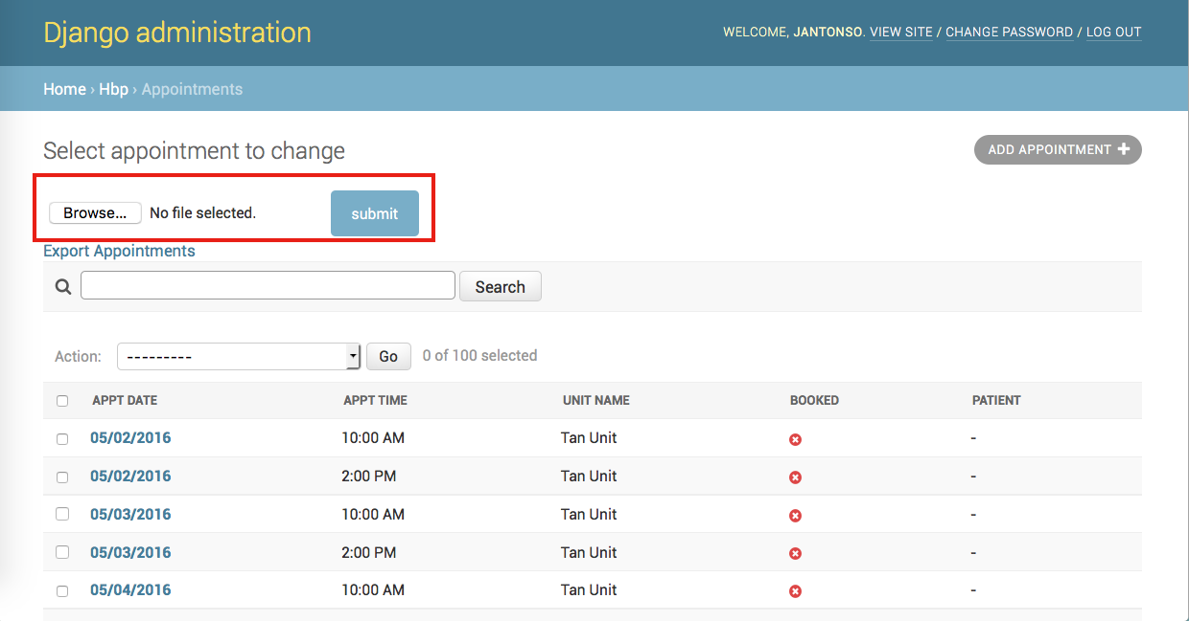

or you can export the appointment information in the database as a CSV file:

1. Click on **Export Appointments**

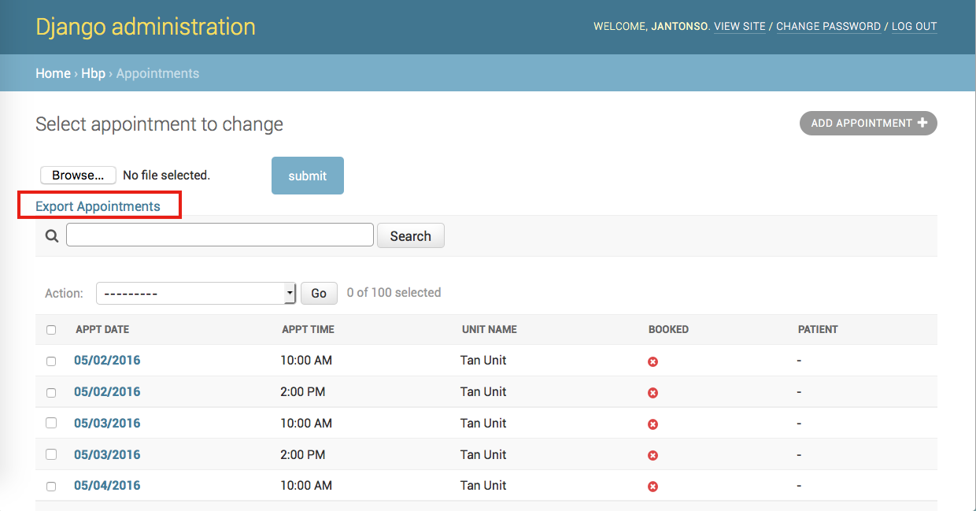

or you can add an appointment manually:

1. Click on **Add Appointment**

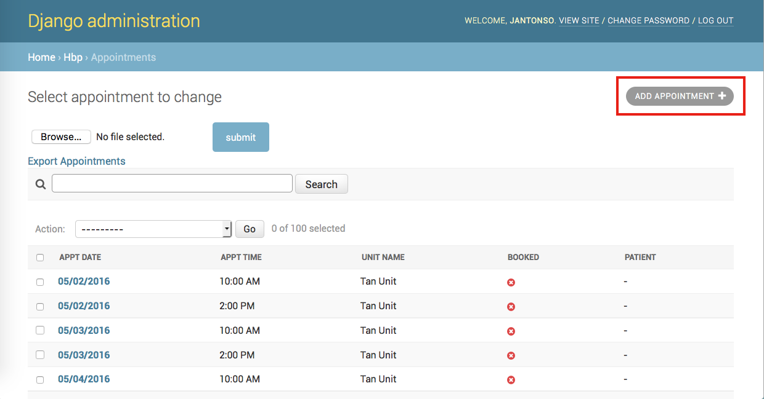

or you can view/edit appointments:

1. Click on an appt date to view that appointment in more detail

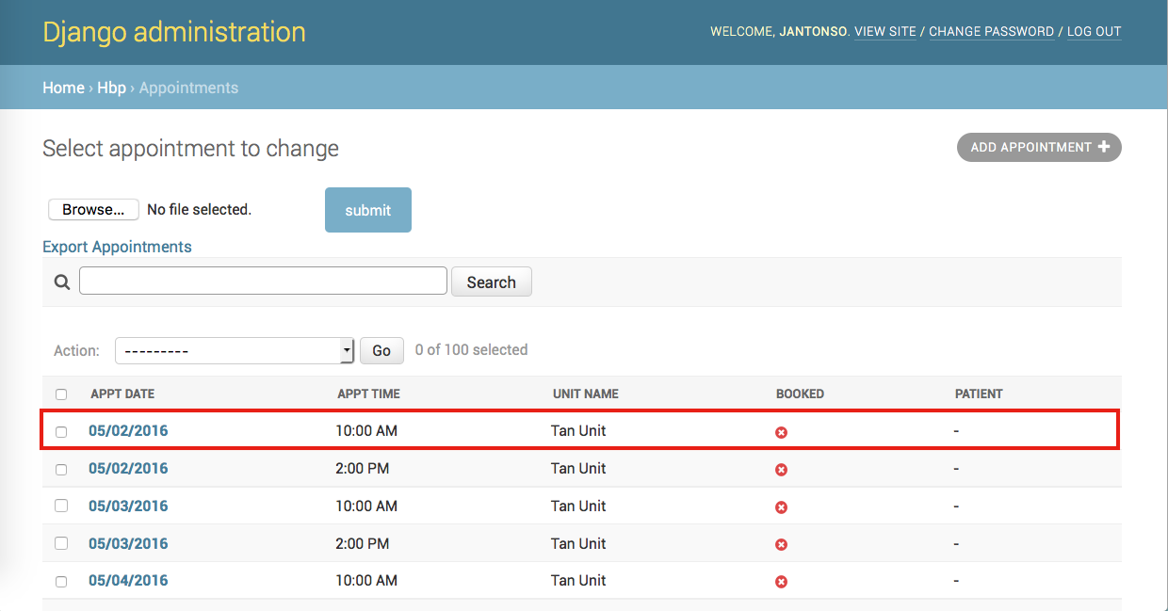

From the patients page, you can export the patient information in the database as a CSV file:

1. Click **Export Patients**

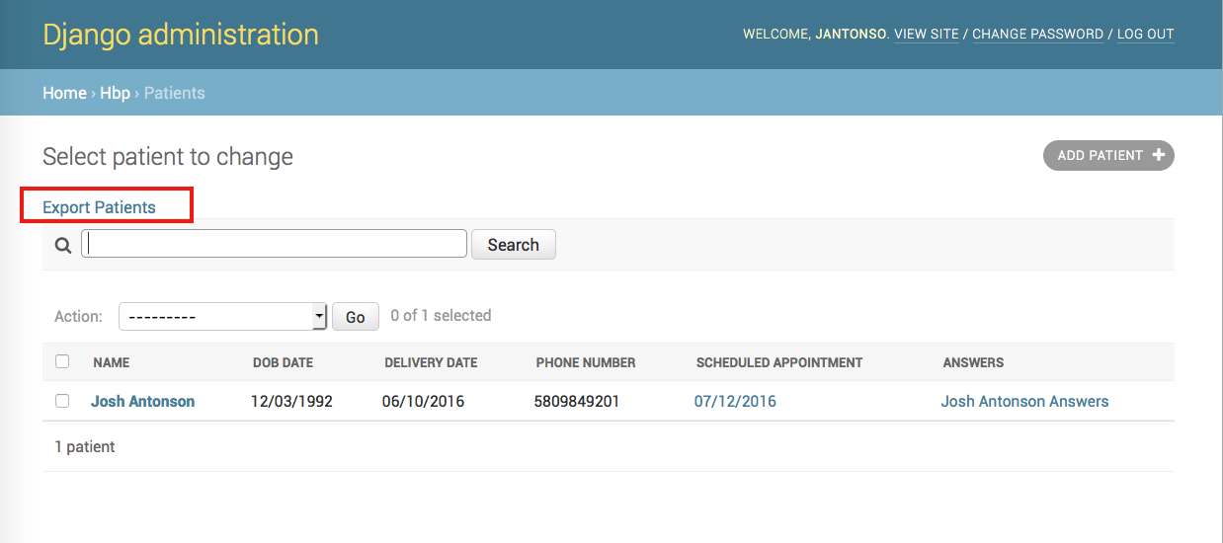

or you can add a new patient manually:

1. Click on **Add Patient**

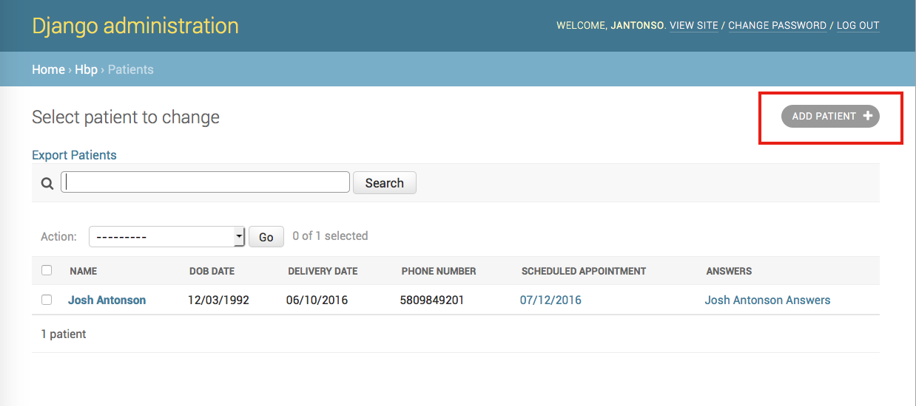

or you can view/edit patients:

1. Click on the patient’s name to view more information about that patient

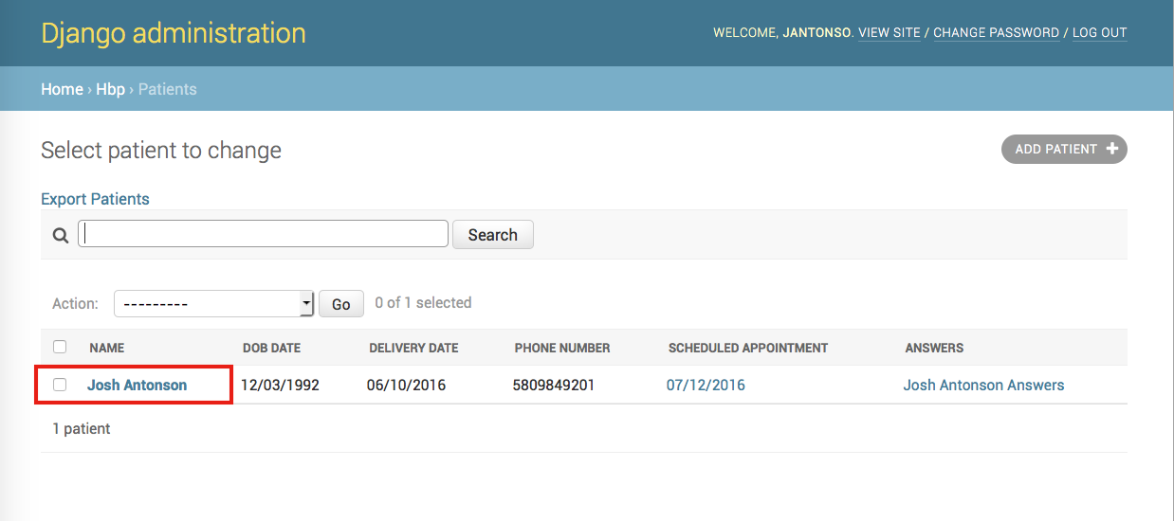

or you can view/edit answers:

1. Click on the patient’s answers to view their answers

